Homework #3

Jacob Taylor Cassady

CECS 627: Digital Image Processing

**Consider the images shown. The image on the right was obtained by:**

1. **multiplying the image on the left by (-1)^(x+y)**
2. **computing the DFT**
3. **taking the complex conjugate of the transform**
4. **computing the inverse DFT**
5. **(3) multiplying the real part of the result by (-1)^(x+y).**

**Explain mathematically why the image on the right appears as it does.**

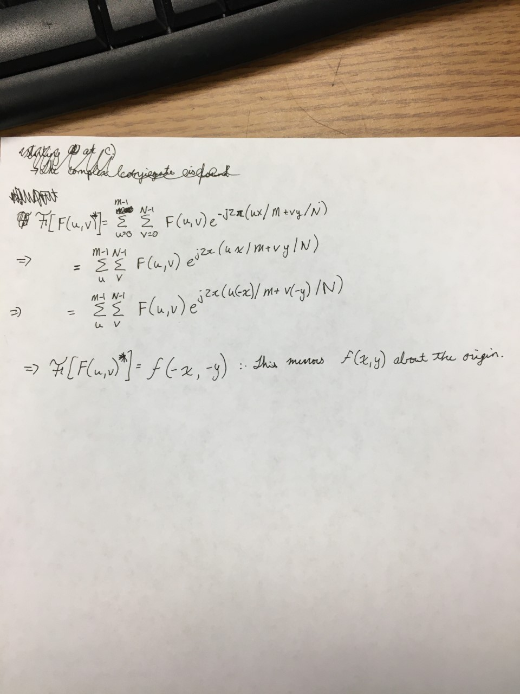

**Consider the sequence of images shown below. The image on the left is a segment of an X-ray image of a commercial printed circuit board. The images following it are, respectively the results of subjecting the image to 1, 10, and 100 passes of a gaussian highpass filter with D0 = 30. The images are of size 3030 x 334 pixels, with each pixel being represented by 8 bits of gray. The images were scaled for display, but this has no effect on the problem statement.**

1. **It appears from the images that changes will cease to take place after a finite number of passes. Show whether or not this is the case. You may ignore computational round-off errors. Let cmin denote the smallest possible number representable in the machine in which the computations are conducted.**
2. **If you determined in (a) that changes would cease after a finite number of iterations, determine the minimum value of that number.**

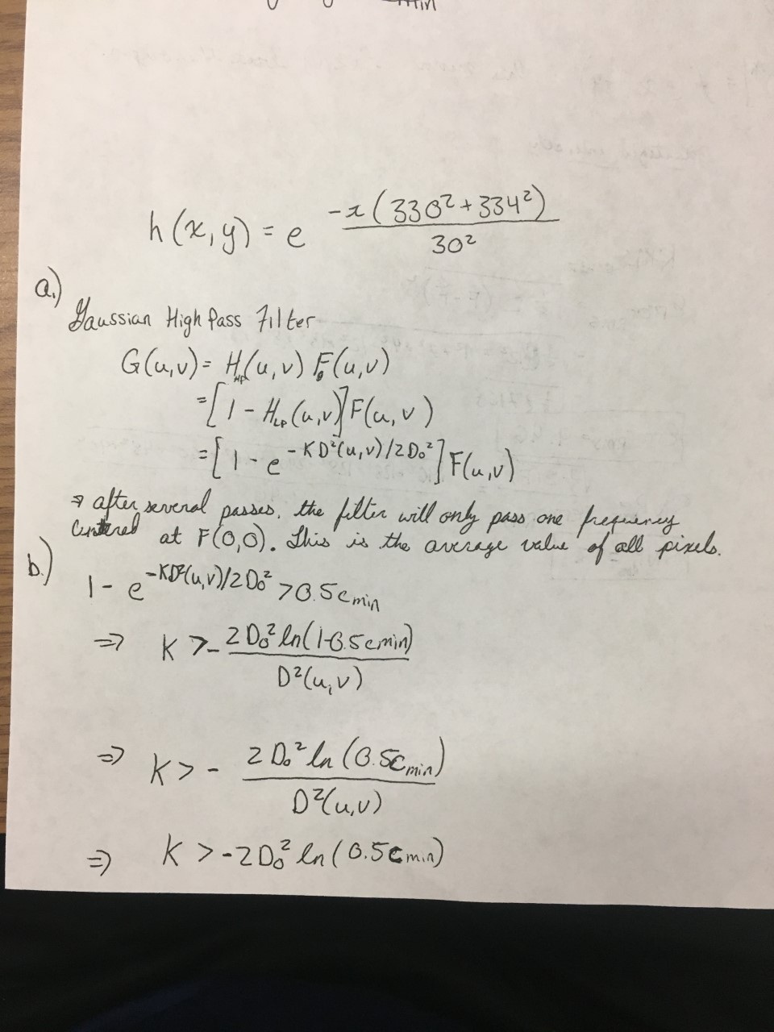

**The white bars in the test pattern shown are 7 pixels wide and 210 pixels high. The separations between bars is 17 pixels.**

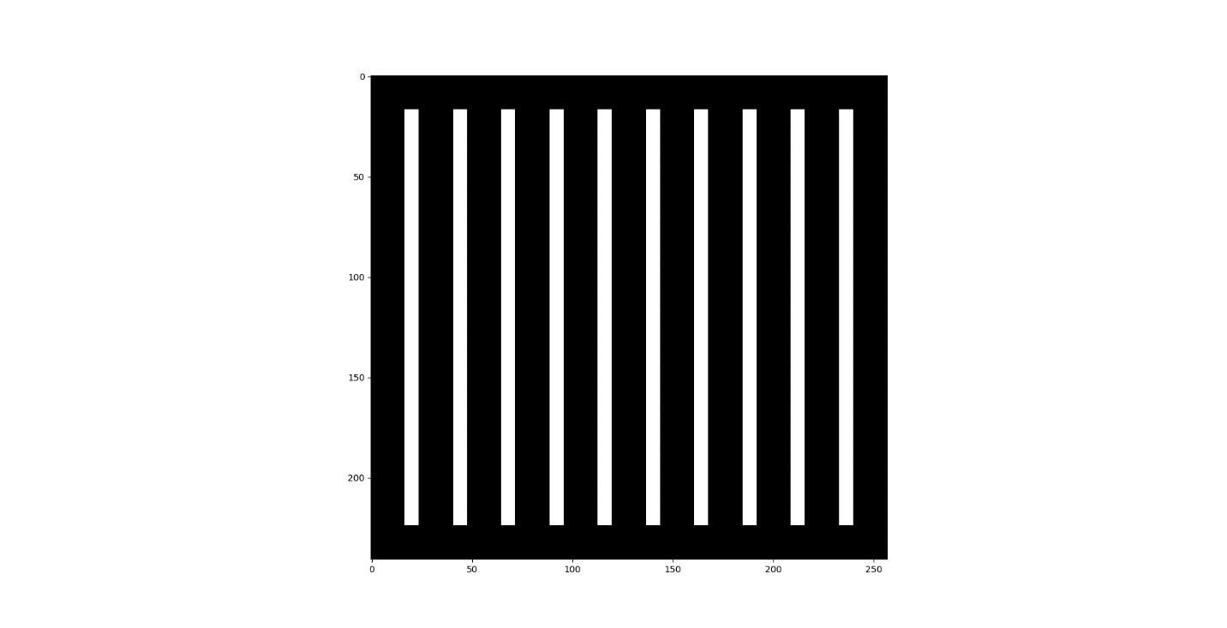

**What would this image look like after application of:**

1. **A 3x3 arithmetic mean filter?**

1. **A 7x7 arithmetic mean filter?**

1. **A 9x9 arithmetic mean filter?**

**Consider an 8-pixel line of intensity data, {108, 139, 135, 244, 172, 173, 56, 99}. If it is uniformly quantized with 4-bit accuracy, compute the rms error and rms signal-to-noise ratios for the quantized data.**

|  |  |  |
| --- | --- | --- |
| Intensity | Quantized Intensity | |Difference| |
| 108 | **96** | **12** |
| 139 | **128** | **11** |
| 135 | **128** | **7** |
| 244 | **240** | **4** |
| 172 | **160** | **12** |
| 173 | **160** | **13** |
| 56 | **48** | **8** |
| 99 | **96** | **3** |

